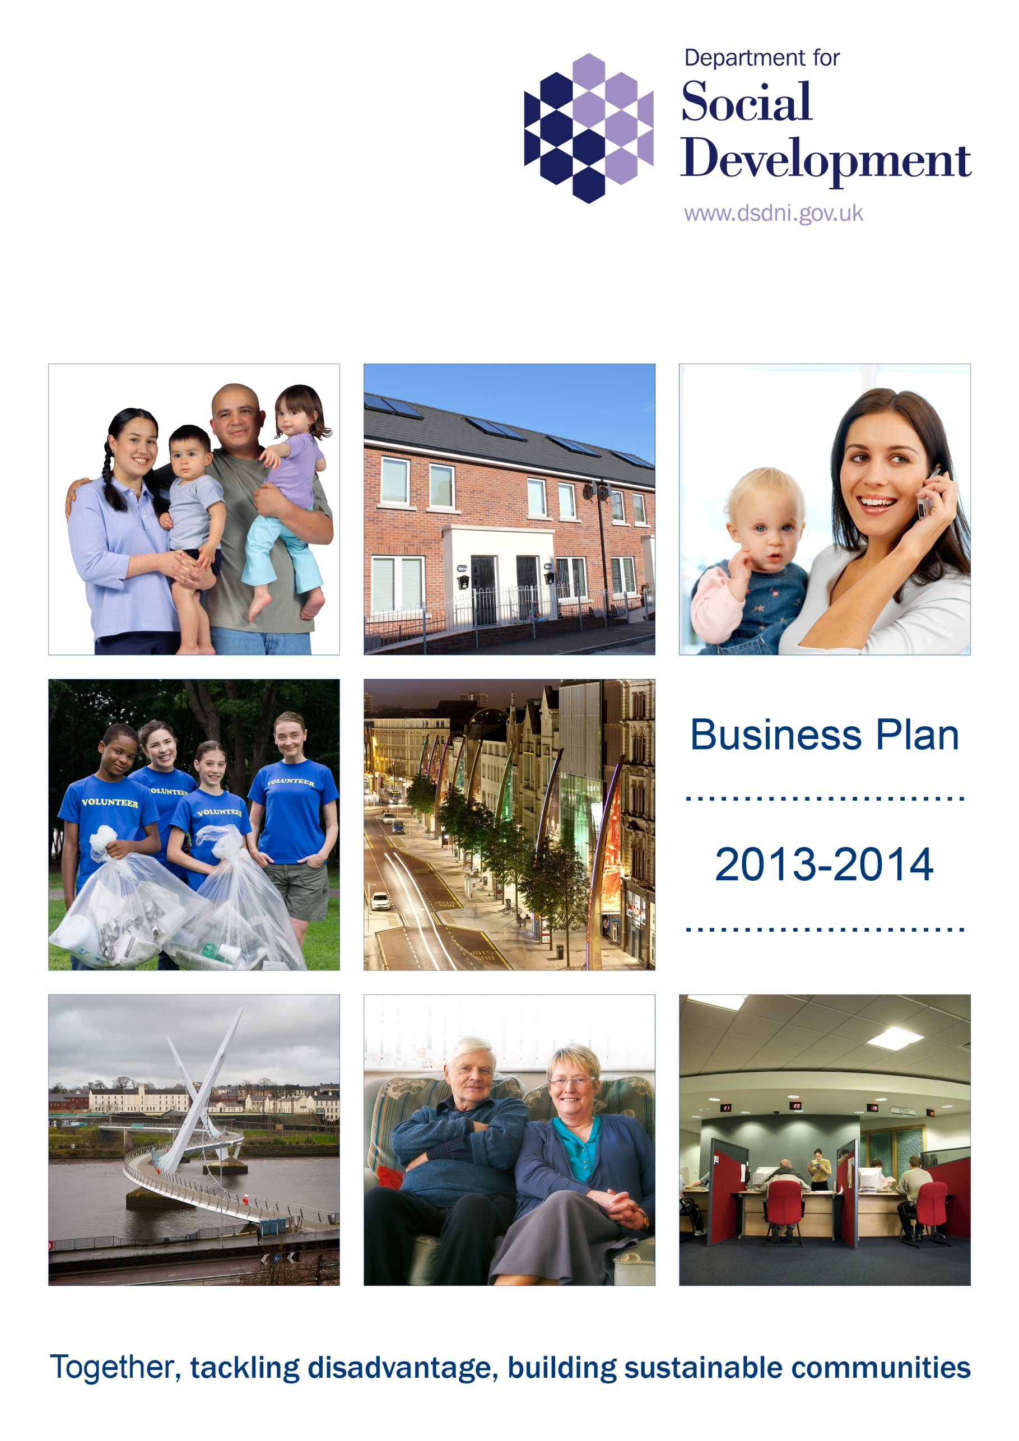
Draft
Contents

1. Introduction 3

2. Monitoring performance 4

3. Commitments and 2013/14 milestones 5

4. Other corporate business plan commitments 14

Appendix 1 – Our resources for 2013/14 19

1. INTRODUCTION

Good progress is being made in delivering on the commitments in our Corporate Plan 2011-2015 which link directly and indirectly to the five priorities of the Programme for Government: growing a sustainable economy and investing in the future; creating opportunities, tackling disadvantage and improving health and well-being; protecting our people, the environment and creating safer communities; building a strong and shared community; and delivering high quality and efficient public services.

Reports on our achievements during 2011 – 2012 and 2012 – 2013 are published on the internet at www.dsdni.gov.uk. This business plan for 2013 – 2014 sets out what we plan to achieve over the next 12 months.

Our mission ‘together tackling disadvantage building sustainable communities’, demonstrates our continuing commitment to our vision helping people change their lives for the better.

Our focus on Housing, Welfare Reform and Strengthened Communities and Vibrant Urban Areas represents our Minister’s priorities for tackling poverty and disadvantage to create a society that is economically prosperous, socially connected and makes the best use of its resources. These themes form the framework for the commitments and milestones we have set to signpost progress towards achieving our objectives which are to:

- provide access to decent, affordable, sustainable homes and housing support services;

- meet the needs of the most vulnerable by tackling disadvantage through a transformed social welfare system, the provision of focused support to the most disadvantaged areas and encouraging social responsibility; and

- bring divided communities together by creating urban centres which are sustainable, welcoming and accessible to live, work and relax in peace.

The delivery of these objectives will require inter-departmental co-operation and work across a variety of work strands, for example during this year Housing will work closely with Regeneration to deliver housing need and regenerate some of our most deprived and neglected communities.

This Plan does not attempt to cover all aspects of our business activities but provides the key commitments and milestones which provide the basis for the development of more detailed plans in business areas which in turn inform the Personal Performance Agreements for our staff.

- MONITORING PERFORMANCE

The Department’s Management Board supports the Permanent Secretary in his oversight of the delivery of this Business Plan. The Board and the Minister receive quarterly performance reports which set out progress against all the commitments and milestones identified in Section 4. This includes a report on performance against delivery of our Efficiency Plans which are published separately on our Internet site www.dsdni.gov.uk.

- COMMITMENTS 2011 – 2015 AND MILESTONES FOR 2013/14

Strategic Theme – Housing
Commitments | 2013/14 Milestone
Deliver 8,000 social and affordable homes (PfG) | 1275 social and 500 affordable homes delivered
Introduce and support a range of initiatives aimed at reducing fuel poverty across Northern Ireland including preventative interventions (PfG) | 9,000 homes improved and SAP improvements of 15% are achieved by 31 March 2014  Boiler Replacement scheme – to provide grant assistance to 5,000 homes by 31 March 2014 to replace old inefficient boilers
Improve thermal efficiency of Housing Executive stock and ensure full double glazing in its properties. (Housing Executive to bring forward a strategy to improve the thermal efficiency of their housing stock including a programme aimed at providing full double glazing by 2014/15) (PfG) | 50% (17,600) completed by March 2014
By the end of 2014/15, to have implemented new structures to support the improved delivery of housing services to the citizens of Northern Ireland (PfG) | By December 2013, develop detailed proposals on Social Housing Reform for engagement with key stakeholders  By 31 March 2014, implement year 1 of Social Housing Reform
To deliver the Northern Ireland Housing Strategy Action Plan | By 30 June 2013, publish the Housing Strategy Action Plan  By 31 March 2014, implement the high priority actions from the Housing Strategy Action Plan and prepare for implementation of the medium-priority actions 2014/15
To assist vulnerable people to live independently | Assist 17,000 people to live as independently as possible
Reduction in the number of social homes failing to meet the agreed standard for social homes | Investment of £78.1m in the planned maintenance improvement programme in 2013/14
A better regulated Private Rented Sector more capable of meeting housing need | Oversee the implementation of landlord registration which is due to go live as soon as possible after June 2013  Oversee the first full year of tenancy deposit schemes and agree parameters for evaluation (due at end of second year of operation) by March 2014

Strategic Theme - Welfare Reform
Commitments | 2013/14 Milestone(s)
In light of NI Welfare Reform changes, reform the welfare system to help to tackle some of the root causes of poverty and mitigate against adverse impact of individual reforms | By 31 December 2013, to have completed the Assembly passage of the Welfare Reform Bill and to have received Royal Assent for the Bill by end of February 2013  By December 2013, to have successfully implemented new Discretionary Support provision in Northern Ireland  By March 2014, to have commenced the implementation of Personal Independence Payment (PIP)  By December 2013, to have implemented Employment and Support Allowance (ESA) time limiting  By December 2013, to have implemented the Benefit Cap  By March 2014, to have completed the unique Northern Ireland aspects of the IT design, build and testing to support the delivery of Universal Credit in Northern Ireland (including Payment Flexibilities)
Percentage increase in those working age claimants in receipt of work focused benefits or on a support programme to enable them to move into work | By March 2014, to have commenced reassessment of the final tranche (33,000) of all Incapacity Benefit (IB) claimants (83,000)
Implement a reformed statutory child maintenance system that will be more efficient and will work for parents, the taxpayer and children | By 31 March 2014, to have implemented the new Child Maintenance Scheme (CMS 2012)  By 31 March 2014, to have completed all required preparation work for the transfer of existing clients to the new Child Maintenance Scheme (CMS 2012), aligning with the overall Child Maintenance Reform Programme

Strategic Theme - Strengthened Communities and Vibrant Urban Areas
Commitment | 2013/14 Milestone(s)
Bring forward a new approach to regeneration which will build on what we know works and will aim to improve the effectiveness and efficiency of regeneration and community development investment. The aim is towards a renewed focus on ensuring that regeneration tackles the underlying economic challenges | By 30 June 2013 publish Urban Regeneration Policy Framework and bring forward a set of outcome measures to monitor progress against the Policy Framework objectives  By 30 September 2013 produce an implementation plan for the new Policy Framework  By 31 March 2014, to deliver DSD Commitments in the Executive EU Priorities 2013/14
Invest in social enterprise growth to increase sustainability in the broad community sector (PfG) | By 30 September 2013, to have agreed implementation arrangements including appropriate support structure for community asset transfer policy and by 31 March 2014 to have the support arrangements in place  By 30 September 2013, to establish at least 10 Delivering Social Change Social Enterprise Incubator Hubs  By 31 March 2014 take forward agreed recommendations as identified in social economy baseline mapping exercise and support the ongoing delivery of the Social Economy Enterprise pilot project
Develop a joined-up approach by the statutory, private and community sectors to maximise the potential regeneration opportunity for Belfast from the expansion of the University of Ulster’s York Street Campus | By 30 November 2013, to initiate a third phase of the Belfast: Streets Ahead programme (BSA 3), by appointing an Integrated Design Team for BSA 3  By 31 December 2013, to initiate a developer competition for the Frederick Street Scheme (subject to planning approval)  By 31 March 2014, to take forward the agreed deliverables for 2013/14 in the Campus Regeneration Opportunity Plan in relation to Public Realm and Planning
Reduce the gap between Neighbourhood Renewal Areas and Non-Neighbourhood Renewal Areas on key deprivation indicators relating to health, community safety, education and worklessness; and in addition respond to issues impacting negatively on areas outside Neighbourhood Renewal Areas through our Areas at Risk Programme | By 30 June 2013 produce an annual report on Neighbourhood Renewal for the period from 1 April 2012 to 31 March 2013  By 30 September 2013, to have established Delivering Social Change Nurture Units in 20 schools  By 31 March 2014, to deliver services to tackle health, community safety, education, worklessness and other inequalities in Neighbourhood Renewal Areas  By 31 March 2014, to have completed a review of the existing Neighbourhood Renewal Programme
Ensure the necessary arrangements are in place to enable local councils to take forward delivery of Urban Regeneration, Tackling Social Need, Community Development and some Housing functions from April 2015 | By 31 March 2014, to have completed an extensive programme of engagement with Local Government and agree implementation plans
Deliver at least 30 schemes to improve landscapes in public areas to promote private sector investment in towns and cities across Northern Ireland (PfG) | By 31 March 2014, to have delivered 10 Public Realm schemes
Bring at least 18 Comprehensive Development opportunities to the market for consideration by March 2015 | By 31 March 2014, to have issued development briefs or initiated competitive procurement for 6 further schemes
To lever in an average of £6 million of private investment through the Urban Development Grant Scheme | By 31 March 2014, to have made at least 12 offers in respect of Urban Development Grant schemes
Implement a Volunteering Strategy to promote and develop volunteering | By 31 December 2013, to have new volunteering infrastructure arrangements in place providing the framework for successful implementation of the Volunteering Strategy  By 31 March 2014, 6 meetings of the Volunteering Strategy Steering Group to have taken place ensuring that at least 8 volunteering innovation projects will have been initiated  By 31 March 2014, to have developed and delivered Phase 1 of a Northern Ireland volunteering/citizenship programme for young people
Continue to work with OFMDFM and Ilex on the regeneration of Londonderry | Up to 31 December 2013, to ensure that the temporary UK City of Culture Events Pavilion is fully functioning and operates within budget  By 31 March 2014, secure outline planning permission for the Fort George Development Framework and progress remediation works in order to facilitate start of construction work on the North West Regional Science park
4. OTHER CORPORATE BUSINESS PLAN COMMITMENTS

The Departmental Management Board will also be monitoring progress on a number of other Corporate Business Plan commitments as set out below:

Commitment | Target
Tackling Homelessness | To continue with the implementation of the Homelessness Strategy through annual action plans, by completing all agreed actions for 2013/14 by 31 March 2014
Modernise service delivery to improve choice and accessibility for benefit claimants | By October 2013, to have Introduced new arrangements to enable mandatory reconsiderations and direct lodgements for benefit appeals  By December 2013, to have implemented Mail Opening, Scanning and Image Circulation (MOSAIC)  By October 2013, to a have developed and agreed a strategy for the future delivery of Telephony Services in the Social Security Agency  By March 2014, to have implemented a programme of enabling actions to support delivery of the Customer Contact Strategy  By September 2013, to have base-lined the Target Operating Model for the administration of Universal Credit when it is introduced in April 2014  By September 2013, to have agreed the criteria and processes for Payment Flexibilities under Universal Credit  By December 2013, to have implemented a delivery model for legacy short-term benefits advances
Ensure benefit claimants are receiving the right benefit at the right time | Income Support - 99%  Jobseekers Allowance - 99%  State Pension - 99%  State Pension Credit - 98%  Disability Living Allowance - 99%  Employment and Support Allowance - 97%  Clearance (days)  Income Support - 8  Jobseekers Allowance - 11  State Pension - 7  State Pension Credit - 9  Disability Living Allowance - 37  Employment and support Allowance - 14
Maximise the uptake of benefits by targeting those likely to be eligible for unclaimed benefit | By March 2014, to have issued an invitation to 25,000 people at risk of poverty offering a full and confidential benefit entitlement check  By March 2014, to have implemented the actions set out in the Year 1 Action Plan of Maximising Incomes and Outcomes, A Plan for Improving the Uptake of Benefits  By September 2013, to have invited bids to the 2013-14 Innovation Fund for Improving the Uptake of Benefits and initiate projects
Implement new arrangements for the delivery of high quality generic and thematic support services across the voluntary and community sector | By 31 December 2013, to have put in place regional infrastructure support arrangements to support Volunteering and Women in Disadvantaged and Rural Areas
Develop and test new ways of collaborative working between government and the voluntary and community sector and promote more effective partnerships within the sector | By 31 March 2014 progress implementation of the agreed recommendations arising from the Report on Addressing Bureaucracy
Advance a range of policy and legislative proposals in support of Social Policy objectives | By 31 March 2014 develop draft legislation to reform law on gambling  By 31 March 2014 introduce arrangements for Business Improvement Districts  By 31 March 2014 bring forward a range of proposals in relation to the reform of the law in liquor licensing  By 31 March 2014 introduce a licensing regime for Pavement Cafes  By 31 March 2014 bring the law on street trading into line with EU Directives
Annual Procurement Plan | Produce the Department’s 2014/15 plan by 31 March 2014
Improve Employee Engagement | To implement the Employee Engagement Strategy and increase the Employee Engagement Index to 40% by 31 March 2014
Reduce Sickness Absence | No more than 11.4 days lost through absence by 31 March 2014
Deliver Effective Resourcing and Workforce planning | Ensure that staff in post levels are at least 95% of baselined posts throughout the year
Complete Review of Industrial Relations Framework | By October 2013, to have completed work on the development of an Industrial Relations Framework for the Department
Take forward the development and implementation of the Career Development Strategy | By March 2014, to have taken forward work on the implementation of the Career Development Strategy for the Department
Implement the Accommodation Strategy | To take forward the agreed action for 2013/14 identified in the Accommodation Strategy by March 2014

Appendix 1 – Our resources for 2013/14
Spending Area | Current £m | Capital £m | Total £m
Social Security Administration | 384.0 | 4.8 | 388.8
Dept Work & Pensions Admin Agency Services | 0.4 | - | 0.4
Sub-Total
 | 384.4 | 4.8 | 389.2
NI Child Maintenance Service Administration | 19.4 | - | 19.4
NI Housing Executive | 188.2 | -39.2 | 149.0
Housing Associations | -0.7 | 105.9 | 105.2
Sub-Total
 | 187.5 | 66.7 | 254.2
Urban Regeneration/Community  Development | 59.7 | 28.0 | 87.7
EU Peace Programme | 0.2 | 1.5 | 1.7
Sub-Total
 | 59.9 | 29.5 | 89.4
Overall Total | 651.20 | 101.0 | 752.20

Due to rounding, the sum of individual totals may not match exactly the sub-totals or overall total in the table.

In addition, the Department has been allocated an Annually Managed Expenditure Budget of £5370 million (£5361 million for Social Security Benefit Expenditure and Financial Assistance Scheme and £9 million for Urban Regeneration Non-Cash Costs). The Annually Managed Expenditure Budget is demand led and consequently subject to change throughout the year.

Further Information

This Business Plan for 2013 – 2014 is available on the Internet at www.dsdni.gov.uk.

Copies can also be obtained by writing to:

Corporate Planning and Governance Unit
4th Floor
Lighthouse Building
1 Cromac Place
Gasworks Business Park
Ormeau Road
Belfast
BT7 2JB

Or by e-mailing cpgu@dsdni.gov.uk

Corporate Planning and Governance Unit can also be contacted by telephone on 028 90 829 502.

Copies in alternative formats or languages will be considered in light of demand.

