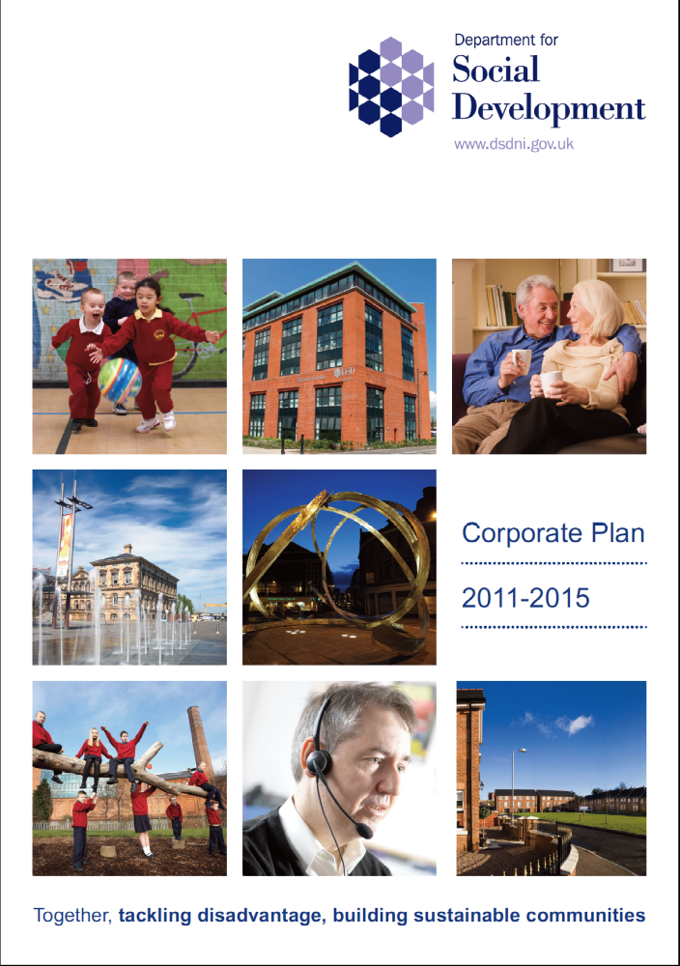

Contents

Ministerial foreword 5

Context and planning influences 8

Our Programme for Government commitments 9

Our corporate plans 11

Our mission, vision and strategic objectives 13

Outcomes 14

Themes 17

Housing 18

Welfare reform 19

Strengthened communities and vibrant urban areas 21

How we do our business 23

Our human resource strategy 25

Key challenges 28

Measuring success 29

Appendix 1 - Our responsibilities 30

Appendix 2 – How our work is organised and monitored 34

Ministerial Foreword
After a year as Minister for Social Development I am very aware of the scale of the challenge we face in tackling disadvantage and building sustainable communities. The ongoing difficulties in the European economy, and shifts within the world markets mean that the priority the Executive places on the economy is well placed and crucial to our future. Those changes impact directly on jobs and all our standards of living. Unemployment levels are continuing to rise as are the numbers of individuals and families seeking support from the Social Security Agency. We have stubbornly high rates of people dependent on benefits compared to the rest of the UK. The coming years will therefore require a great deal of hard work to lay the foundations of growth, to support individuals and communities in tackling unemployment and worklessness and to ensure that our most vulnerable citizens are supported and protected.

That is core to my Department’s mission. Delivering a budget of almost £6 billion per annum through 6000 staff, most of our work is focused on our most disadvantaged citizens, families and communities; through social security, child maintenance, providing social housing, addressing homelessness and supporting our poorest communities through neighbourhood renewal. That work together with our responsibilities for revitalising our town and city centres means we have an impact on every residential area, community and town across Northern Ireland. And there are huge challenges ahead of us; implementing welfare reform, fundamentally reforming our approach to the provision of social housing and tackling the problems of our most disadvantaged communities will not be easy.

Tackling poverty is a significant challenge in this difficult economic climate.
Over the period of this plan, we will work with the Executive through the Programme for Government to get people into work; and to ensure that our poorest communities can participate in the growth of our economy and help lift them out of poverty, looking at ways of building the social economy and social enterprise and exploring new models for urban regeneration. My Department will play its part in contributing to the Executive’s top priority of growing our economy to create more jobs through our housing programme; through encouraging social enterprises in our poorest communities; and through attracting investment to make our towns and cities more attractive and more successful.

Unemployment and poverty go together and this has particularly damaging consequences when unemployment passes on in families to second and third generations. We will explore new ways to develop more effective policies which are relevant to the needs of different generations, where dependence on welfare benefits and social housing has become a life choice, and where pensioner poverty is an inevitable consequence.

We will make the best possible use of increasingly limited resources and will explore the potential for sharing services and increasing levels of voluntary activity in our communities, working with other departments and with the voluntary and community sector, to tackle poverty and its roots.

We want to improve the quality of life and well-being of individuals and families and engender a sense of hope and aspiration for a better future. I will lead developments that will engage with communities to focus more closely on the economic drivers that will help to lift our most disadvantaged communities out of poverty. We must build strong, sustainable communities that are economically prosperous, socially connected and make the best use of their resources.

And we must break the generational cycle of impoverished and workless individuals, families and communities once and for all. We must find opportunities to transform our communities into hubs of social and economic activity, building communities that are stronger, and where people can live, work and relax in peace.

This will not be easy. My Department will provide support for those who need it; we will work to protect the vulnerable and together with my Executive colleagues to grow an economy that can provide the jobs people need. But we cannot do this alone. government has a responsibility to create employment, but communities, families and individuals have a responsibility to encourage and support self help to take up the opportunity of suitable employment and to play their full part in addressing these very difficult economic times.

I am committed to the challenge and look forward to working alongside our

communities with public and private sector partners to help people change their lives for the better and together, tackle disadvantage and build sustainable communities.

Nelson McCausland
Minister for Social Development

1. Context and Planning Influences
This Plan sets out our approach to social development. It describes the context in which we will be operating and how we contribute to improving the quality of life and well-being of society in Northern Ireland, linking to the Programme for Government aims and priorities 2011 – 2015.

ACCOUNTABILITY
COMMITMENTS AND MILESTONES
CORPORATE PLAN
BUSINESS PLANS
PROJECT PLANS
PROGRAMME FOR GOVERNMENT 2011-15
OUTCOMES
MISSION
VISION
GUIDING PRINCIPLES,
CULTURE and VALUES
DEPARTMENTAL
STRATEGIC
OBJECTIVES
2. Our Programme for Government Commitments
The Programme for Government 2011 – 2015 provides the overarching direction for the Department’s work, and, together with the Budget and Investment Strategy, establishes the basis for setting our priorities and plans going forward.

The 5 priorities for the Programme for Government are:

- Growing a sustainable economy and investing in the future;

- Creating opportunities, tackling disadvantage and improving health and well- being;

- Protecting our people, the environment and creating safer communities;

- Building a strong and shared community; and

- Delivering high quality and efficient public services.

As a Department, with our strong mission to tackle disadvantage, we contribute directly and indirectly to all of these priorities. Our work has far reaching effects on the lives of everyone in Northern Ireland, regardless of age, gender, marital status, religion, disability or none. From the pensioner needing support with fuel payments, to those with disabilities needing support, to those facing unemployment, to parents living apart and needing to agree support for their children, we have a major responsibility. So too for those seeking appropriate housing they can afford, or for communities which have significant social and economic problems, DSD and its agencies make major investments, providing new houses and protecting tenants, supporting early years programmes for children, improving the environment of estates and helping communities develop. In our towns and cities, working with councils and developers, we help plan for and deliver new public areas and buildings, so we can have vibrant, shared civic centres.

The key priorities we contribute to the Programme for Government are set out below. Milestones relating to these priorities are contained in a separate annual Business Plan, which is published on our internet site at www.dsdni.gov.uk.

Priority | Commitment
1. Growing a sustainable economy and investing in the future | Invest in social enterprise growth to increase sustainability in the broad community sector
2. Creating opportunities, tackling disadvantage and improving health and well-being | Deliver 8,000 social and affordable homes
 | Introduce and support a range of initiatives aimed at reducing fuel poverty across Northern Ireland including preventative interventions
Improve thermal efficiency of Housing Executive stock and ensure full double glazing in its properties

(To have the Housing Executive bring forward a strategy by March 2012 to improve the thermal efficiency of their housing stock including a programme aimed at providing full double glazing by 2014/15)

4. Building a strong and shared community | Deliver at least 30 Schemes to improve landscapes in public areas to promote private sector investment in towns and cities across Northern Ireland
5. Delivering High quality and efficient public services | By the end of 2014/15, to have implemented new structures to support the improved delivery of housing services to the citizens of Northern Ireland

3. Our Corporate Plans
In this Corporate Plan for 2011 – 2015 we set out our approach to delivering on our commitments in the Programme for Government, including the strategic objectives and outcomes we have set which align with the Programme, and contribute to the Executive’s priorities. Information on all other departmental commitments is included under our three key themes of Housing, Welfare Reform and Strengthened Communities and Vibrant Urban Areas.

Also included (at Appendix 1) are full details of our responsibilities as the Government Department responsible for Social Development, and at Appendix 2, we have included further information on how our work is organised and monitored.

Internet and Other Access to our Plans
A copy of this Plan is available on the Internet at www.dsdni.gov.uk.
Copies can also be obtained by writing to:

Corporate Planning and Governance Unit
4th Floor
Lighthouse Building
1 Cromac Place
Gasworks Business Park
Ormeau Road
Belfast
BT7 2JB

Or: by e-mailing cpgu@dsdni.gov.uk/ Phoning - 028 90 829 502.

Copies in alternative formats or languages will be considered in light of demand.

Together, tackling disadvantage, building sustainable communities
Our Mission
Our People
Our Strategic Objectives

“Provide access to decent, affordable, sustainable homes and housing support services”
“Meet the needs of the most vulnerable by tackling disadvantage through a transformed social welfare system, the provision of focused support in the most disadvantaged areas and encouraging social responsibility”
“Bring divided communities together by creating urban centres which are sustainable, welcoming and accessible to live, work and relax in peace”
Improving quality of life and wellbeing
Outcomes

A Society that is economically prosperous; socially connected; and makes the best use of its resources

Tackling Poverty and Disadvantage

Themes
The way we do
our business

Housing

Strengthened Communities and Vibrant Urban Areas
Welfare
Reform
We act fairly and honestly

We deliver quality services

We are connected

We are proud of what we do

Helping people change their lives for the better

4. Our Mission, Vision and Strategic Objectives

Our mission ‘Together, tackling disadvantage, building sustainable communities,’ describes broadly our aspirations for the future of communities in Northern Ireland. Our vision is ‘helping people change their lives for the better’, improving the quality of life and well-being of our society which aligns with the Programme for Government aim of ‘a shared and better future for all.’

We have set ourselves three challenging objectives which will focus our activities.

Over the period of this Plan we will:

- provide access to decent, affordable, sustainable homes and housing support services;

- meet the needs of the most vulnerable by tackling disadvantage through a transformed social welfare system, the provision of focussed support in the most disadvantaged areas and encouraging social responsibility; and

- bring divided communities together by creating urban centres which are sustainable, welcoming and accessible to live, work and relax in peace.

5. Outcomes

Together, Tackling Disadvantage, Building Sustainable Communities
Economically Prosperous
Socially Connected
Makes the best use of its
resources
Helping people change their lives for the better

Where we have come from

We have made a lot of progress over the years to address issues of poverty and disadvantage and building communities in Northern Ireland. During the last Programme for Government for example Housing targets were exceeded; a substantial programme of improvements to our towns and cities was delivered; through neighbourhood renewal many hundreds of projects were delivered to support our poorest communities; the Social Security Agency recorded its best ever performance levels, we collected significant levels of money for children through our child maintenance arrangements and approximately 23,000 people benefited from the Supporting People Scheme.

What we want to achieve over the longer term

We want Northern Ireland to be a sustainable society underpinned by the principle of social responsibility, a strong and shared community; a society in which people from all walks of life, regardless of their political persuasions, race, sexuality, disability or none, marital status, or income, share facilities and environments and have a stake in a common future.

Over the longer term our work will be firmly focused on delivering positive and lasting changes that will create a society which is:

- Socially Connected – encouraging and supporting positive engagement between people in communities to create a greater sense of participation, responsibility and shared purpose.

- Economically Prosperous – encouraging and promoting economic activity in communities, attracting inward investment, seeking to improve public services in a value for money way and promoting sharing of resources between communities with the aim of helping to reduce relative levels of poverty and an increase in the prosperity of the general population.

- Makes the Best use of its Resources - encouraging communities to take up the baton of responsibility for maintaining and caring for their environments in an appropriate manner to support the Department’s investment in their area; and responding to the diverse needs of the population, providing opportunity and choice and contributing to a better quality of life and a general sense of well-being.

These are long-term outcomes and we have to be realistic about what we can achieve over the period of this Plan. We are operating in a tough economic climate and this is unlikely to change over the short to medium term. However, we will do all that is possible to maximise the resources that are available to us. We will aim to work more smartly and more efficiently - joining up across the Department, involving local communities and others across government and other sectors to deliver on our commitments, firmly focusing on our longer term aspirations and exploring new and more effective and sustainable solutions to the problems faced by individuals, families and communities.

For example we will:

- implement new arrangements for the delivery of high quality generic and thematic support services across the voluntary and community sector;

- develop and test new ways of collaborative working between Government and the voluntary and community sector and promote more effective partnerships within the sector;

- work with the Department of Enterprise, Trade and Investment to research the potential for social economy enterprise growth within the wider voluntary and community sector; and

- develop a policy framework for community asset transfer across Northern Ireland.

6. Themes
Most of our work addresses the needs of those individuals, families and communities who are the most disadvantaged. Tackling disadvantage is an increasingly pressing responsibility because of the inherent risks for those who are poor in a declining economy. Equally important will be taking forward policies that provide the incentive and opportunities for people to be part of our efforts to create a successful economic future. Employment is the best route out of poverty for individuals, for families, for communities. Social policies developed by this Department will increasingly work to complement the wider economic objectives of the Executive.

Through welfare reform, through our developing housing strategy and through neighbourhood renewal and urban regeneration we will focus on initiatives that can build our economy, provide jobs, make our towns and cities more attractive places to invest and visit.

Our approach will be realistic. We recognize the reality of limited budgets and the need to prioritise our expenditure. We will support self reliance of individuals and of communities whilst guaranteeing the protection of the most vulnerable, focusing on achieving the maximum engagement in growing the economy to meet the different but linked needs of different generations. Only through such an approach can we hope to achieve sustainable outcomes, to ensure that future generations have a sound economic future. And we will work to achieve the maximum understanding, support and consensus across the community for our actions aimed at tackling poverty.

Our aim then is not just to alleviate poverty, but to work to help address its roots and enable individuals and Northern Ireland as a whole find its way to a more prosperous future. Core to this is to support those who can to gain skills and employment, and to be able to take full responsibility for their lives and those of their families.

Our priorities are set out within the following key themes:

Housing

Housing is central to individuals well-being and quality of life, be it the ability to access social and affordable housing, either as a tenant or a first time buyer, or enjoying a warm well insulated home that helps tackle some of the causes of fuel poverty. Housing is central to family life and personal well-being, and it is essential that we have a dynamic private market as well as accessible and sustainable social housing. The investment we make in Housing also has knock on effects across the construction, supply and delivery sectors. Whether that is through new build, from house purchase or insulation and maintenance, it all contributes to the economy and consequently helps to tackle poverty.

The last decade has seen a significant change in the Northern Ireland housing market. Economic uncertainty and changes in mortgage lending criteria mean that many first time buyers are still unable to enter the housing market. Market conditions have halted the long-term rise of home ownership, which now accounts for 62% of all dwelling stock. At the same time, the private rented sector has grown considerably with 17% of all stock now in that sector.

Demand for social housing has grown during the last decade, with nearly 40,000 now seeking social housing, and just over 20,000 of these categorised as having a high level of need.

Population growth and the rate of household formation have a considerable impact on the demand for housing. Segregation also remains a key factor in much of Northern Ireland’s housing. Much has been done in recent years to create more opportunities for shared housing, particularly in the social housing sector. However, much more remains to be done if the aspirations of 80% of people who expressed a desire to live in a shared neighbourhood are met.

As in Great Britain, housing in Northern Ireland is also characterised by income segregation. This has led to considerable concentrations of poorer households in
particular areas. There is a body of evidence which demonstrates a number of social, economic and health benefits of mixed income communities.

Climate change poses considerable policy challenges across Government. Housing contributes significantly to the emission of greenhouse gases, with 18% of all emissions in Northern Ireland coming from the residential sector. Volatile energy prices in recent years have also increased the proportion of households in fuel poverty.

There are also clearly demonstrated causal links between poor housing and poor health. While the standard of housing in Northern Ireland is generally good, it is important that we ensure that standards are maintained and remaining poor housing is tackled.

Against this background, and in addition to our Programme for Government commitments, we will therefore:

- develop and consult on a new Northern Ireland Housing Strategy;

- reduce the number of social homes failing to meet the agreed standard for social homes;

- better regulate the Private Rented Sector; and

- assist vulnerable people to live as independently as possible.

Welfare reform

The aim of our social welfare system is to protect those most in need and to help those who are unemployed, through work, to become part of a developing economy. Nearly one-third of our population are receiving some form of social security benefit, nearly 60,000 children live in poverty, and a large number of them live in households where no adult is working. The current level of claims is unlikely to be sustainable in the long term. Our approach to welfare reform and to tackling poverty then must be focused on reducing benefit dependency, whilst protecting the most vulnerable.

This will be one of the most significant pieces of reform that will impact in the coming decade, and will have major impacts on individuals and to the way we finance housing. The work of many other departments and agencies will be impacted, and there will be a major need for a coherent overall approach, across all areas of social policy, to support this change and ensure that the vulnerable are protected and those who can move back to work are given the right support.

During the period of this Plan we will:

- reform the welfare system to tackle the root causes of poverty and mitigate against the negative impact of individual reforms; and

- increase the percentage of those working age customers in receipt of work focused benefits or on a support programme to enable them to move into work.

Our approach to child maintenance reform will also assist families by encouraging them and enabling them to take financial responsibility for their children. There will be a clear commitment to supporting and strengthening family support services and the reformed child maintenance system will focus on positive outcomes for families and children by:

- providing services that encourage family based child maintenance arrangements;

- providing information and support for separated and separating families; and

- implementing a reformed statutory system that will be more efficient and will work for both parents, the taxpayer and children.

Strengthened Communities and Vibrant Urban Areas

Over the past decade, significant investment in regeneration and community development has delivered improvements in outcomes for those who live in the most disadvantaged areas; and has helped to narrow the gap between the most deprived areas and the rest of Northern Ireland. However, in the current economic climate we believe the time is right to shift the emphasis to tackling the economic challenges that hold back deprived areas. To ensure sustainable improvements in housing, community safety, health and educational attainment, we need to tackle the underlying economic challenges.

The current economic conditions present a particular challenge. The tightening of the credit market, uncertainty in the housing market and slower economic growth are all going to have impacts on the challenges facing deprived areas and the potential for achieving the transformative change through regeneration.

We will seek to ensure that investment in regeneration and community development is co-ordinated and prioritised in the right places, with public, private and third sector organisations working together in the same places towards shared outcomes. We want to see regeneration better targeted and co-ordinated, based on a shared strategy to improve deprived areas. In particular we want to ensure that it is linked effectively to improvements in the housing stock. It is this joined up approach, linking community development, regeneration and housing that can effect significant change. Regeneration and community development in the future will be defined by the outcomes they achieve, rather than the process followed. We aim to move towards the underlying sustainable outcomes that really matter for the long-term regeneration of communities. In carrying forward this work we will work alongside colleagues in the Office of the First Minister and deputy First Minister to ensure that work supported by other departments is planned to ensure maximum impact.

During the period of this Plan we will therefore:

- bring forward a new approach to regeneration which will build on what we know works and will aim to improve the effectiveness and efficiency of regeneration and community development investment. The aim is towards a renewed focus on ensuring that regeneration tackles the underlying economic challenges;

- reduce the gap between Neighbourhood Renewal Areas and Non-Neighbourhood Renewal Areas on key deprivation indicators of health, community safety, education and worklessness; in addition we can respond to issues impacting negatively on areas outside Neighbourhood Renewal Areas through our Areas at Risk Programme;

- introduce a new programme to tackle deprivation and regenerate our most deprived areas;

- develop a joined-up approach by the statutory, private and community sectors to maximise the potential regeneration opportunity for Belfast from the expansion of the University of Ulster’s York Street campus;

- bring at least 18 Comprehensive Development opportunities to the market for consideration by March 2015;

- lever in an average of £6 million of private sector investment through the Urban Development Grant Scheme;

- implement a Volunteering Strategy to promote and develop volunteering; and

- continue to work with OFMDFM and Ilex on the regeneration of Derry/Londonderry.

7. How We Do Our Business

Engaging with our staff we have identified the following values and behaviours which will help to shape the way we work:

We deliver quality services – We will set challenging targets for our work and delivering on our promises. We will be innovative and challenge inefficiency and continuously seek to improve our services and understand and respond to customer needs.

We act fairly and honestly – We will act impartially and objectively in everything we do, we will be open and transparent and treat people with respect in our dealings with them. We will seek to foster trust at all times and respect confidentiality.

We are connected – We will seek and act upon the views of customers and staff. We will gain staff commitment through involvement and recognition. We will seek to communicate effectively and work as a team, sharing best practice and working collaboratively within the Department and with others outside it.

We are proud of what we do – We will celebrate success and recognise achievement. We will challenge negativity. Our leaders will inspire and motivate and lead by example. We will take responsibility for achievements and learn from our mistakes, while striving to improve. We will aim to make a difference in the work that we do and ensure our staff feel valued for their contribution.
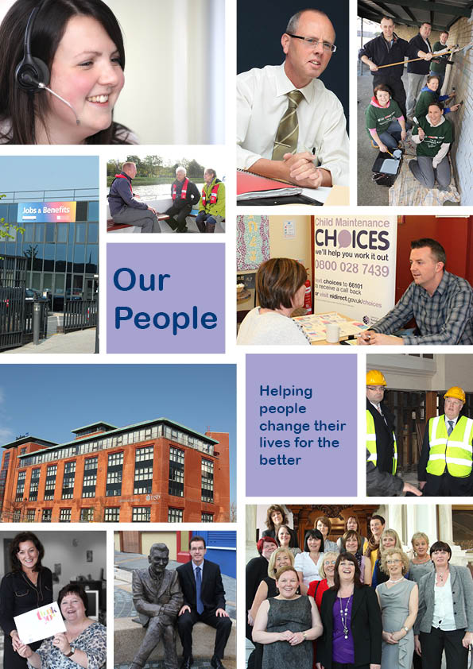

8. Our Human Resource Strategy
Our vision for Human Resources is ‘to ensure that we have the right people with the right skills in the right place at the right time’. Our Human Resources Delivery Strategy 2010-13 was produced in 2010. It considers the challenges and business priorities of the Department and identifies 6 core themes. These are outlined below.

Managing the change agenda
Given the considerable challenges the Department is likely to face in the coming years, it is important staff are prepared for change and are willing to engage in continual service improvement. A key element of this process will be the implementation of a refreshed Industrial Relations framework. This should ensure a more effective consultation process which will support organisational change and new ways of working. We will also take forward work on learning and development programmes to support managers as they take forward and lead change.

Improved attendance
We are committed to the continuous improvement of the health of our staff. Over the course of this corporate plan, we will continue with the implementation of the departmental Health and Well-being Strategy which has three key themes of prevention, early intervention and responsibility. We will actively promote health and well-being in the organisation, and take forward the action required in implementing the new NICS Health and Wellbeing Strategy. We will also work with managers and individual members of staff, as well as our partners such as the Occupational Health Service and Carecall to deliver this strategy.

Ensuring the delivery of effective human resource policy at corporate and departmental level
The challenges ahead under welfare reform and modernisation will require changes to current NICS Human Resource policies in areas such as working hours for staffing the new service delivery models, along with a more flexible approach to recruitment and contracts of employment. We have started engagement with Corporate Human Resources in the Department of Finance and Personnel on the changes required and will take forward work to ensure that Human Resource policies support our business needs.

Resourcing and workforce planning
It is essential that the Department has the resources necessary to deliver against its priorities. We will continue to refine our workforce planning model and the processes associated with recruitment and deployment of our staff to ensure we maintain the staffing levels we need to deliver our services. During the period of the Corporate Plan, we will develop a new career development strategy aimed at ensuring that our staff have the opportunity to enhance and develop their skills, experience and talents, and to put them to good use in improving our business delivery.

Refreshed reward and recognition
Staff are key to the success of the Department and it is important that their contribution is recognised both at an individual and team level. Based on best practice, we will seek to find new ways to recognise high performance. Work will also continue to ensure that the current performance management system is effectively used across the Department.
Engagement
We know that an engaged workforce can have benefits for the Department and for staff. Following the last NICS-wide Staff Attitude Survey and a series of staff focus groups, work will be taken forward to raise levels of staff engagement across the Department, and to take forward a programme of action to address issues from the 2011 Staff Attitude Survey. We plan to establish a Steering Group to co-ordinate action, and have focus groups to better understand staff concerns. All business areas in the Department will have specific action plans for engagement, and work is planned on embedding new values and associated behaviours in the Department to underpin how we deal with our customers, colleagues and business partners.

Accommodation services
In addition to these 6 core themes, it is recognised that our working environment also plays an essential part in supporting the services we deliver. In light of this, and to take account of the business challenges we face, a new Accommodation Strategy will be agreed and finalised. It will provide the direction of estate management over the next number of years with the emphasis on reducing costs. We will also take forward business sustainability plans to increase energy efficiency.

9. Implementing our Plans

Key challenges

In implementing our Plans, there are a number of key challenges. The reduction in the capital funding allocation, arising as a result of the Budget 2010 settlement, will significantly impact on the delivery of social housing and regeneration projects. We are committed to ensuring that maximum benefit is obtained from the resources which are available and are actively examining how income can be obtained from other sources. We will continue, where possible, to leverage in additional funds from the private sector through the budget period. We will also explore opportunities that exist to access European Union funding which can be drawn down to support the work of the Urban Regeneration and Community Development Group and will continue to investigate a number of alternative funding mechanisms to ascertain whether they could be used to raise more funds for the delivery of social housing.

We seek to maintain parity with Great Britain in the area of welfare benefits and child support but also wish to ensure that there is sufficient operational flexibility to take account of local differences in Northern Ireland. A major process of reform will take place over the budget period which will revolutionise how welfare benefits are administered. The exact scale and nature of the changes are as yet unknown, however, we have engaged with the Department for Work and Pensions, which is leading on this programme of reform, to ensure we receive early notification of planned changes. We will put plans in place to ensure our customers experience a smooth transition from the current arrangements to any new arrangements.

We will continue to work with the voluntary and community sector and others in government to strengthen relationships, create the environment in which an enterprising and sustainable sector can thrive and deliver services in the most efficient and effective way possible, active citizenship and where volunteering flourishes, and strong self reliant communities are built.

We will ensure that our staff, as key stakeholders in all our processes, are equipped with the necessary skills to enable us to deliver on our goals. Our Human Resource Strategy as outlined in Section 8 is an important support tool for our work.

We will also work closely with the Department of the Environment and other key departments as well as local government to ensure the effective transfer of an agreed package of functions to the new councils under the Reform of Public Administration.

Communications

To help us deliver on our commitments we will ensure our communications are effective, clear and relevant. Work is currently underway to scope out the communications we will face in the coming years and a draft corporate communications strategy has been prepared. Much work has already been done to improve internal communications across the Department and it is important that staff in all areas and at all levels realise the importance of good communications practice in their day to day work.

10. Measuring Success

We have systems in place that will measure how well we are performing against the targets we have set ourselves in our corporate and business plans. Progress will be reported to our Board, the Minister and the Executive and an annual report on performance will be published on our Internet site.

Appendix 1
Our Responsibilities

The Social Security Agency:

- assesses and pays social security benefits accurately and securely;

- gives advice and information about these benefits;

- supports people by helping them move closer to work;

- handles benefit reviews and appeals;

- prevents and detects benefit fraud, prosecutes offenders and recovers any benefit which has been paid incorrectly;

- recovers benefit which has been paid in compensation cases;

- assesses people’s financial circumstances if they are applying for legal aid; and

- provides services to clients in Great Britain on behalf of the Department for Work and Pensions in Great Britain.

Information on the work of the Social Security Agency can be accessed via our website at www.dsdni.gov.uk/index/ssa.htm

Further information can also be obtained by writing to:
Social Security Agency Chief Executive’s Office,
5th floor Lighthouse Building,
1 Cromac Place, Gasworks Business Park, Ormeau Road, Belfast BT7 2JB
028 90829553

Resources and Social Policy Group

The Group is responsible for:

- corporate finance and negotiating and managing the allocation and control of the Department’s resources;

- personnel and support services;

- social security, pensions and child support policy and legislation separate from, but administered in parity with, the corresponding legislation and services in Great Britain;

- housing policy and legislation;

- overseeing the private rented sector in Northern Ireland;

- providing advice and guidance relating to Housing Benefit;

- oversight and funding of the Northern Ireland Housing Executive, which also administers housing benefit to the rented sector and the Supporting People programme on behalf of the Department;

- securing funding to meet the needs of the housing programme delivered primarily through the Housing Executive and registered Housing Associations. (These organisations receive grant funding from the Department, which they supplement with income from capital receipts, rental income and, in the case of the registered Housing Associations, from private finance. The Department is responsible for the oversight of these organisations to ensure that expenditure is in line with Government’s plans. The Department and the Housing Executive also engage with a number of other statutory and voluntary agencies regarding housing matters);

- child maintenance services, including the promotion of financial responsibility and the provision of information and advice;

- sharing some responsibility for the Appeals Service (Northern Ireland) with the Courts Service. This is an interim arrangement until legislation to move the Service to the NI Courts and Tribunal Service is enacted. The Appeals Service (Northern Ireland) provides administrative support to the independent tribunals set up by legislation to hear appeals against decision makers in the Social Security Agency, Child Maintenance and Enforcement Division, Her Majesty’s Revenue and Customs, the Northern Ireland Housing Executive and Rates Collection Agency;

- the Department’s Internal Audit function.

For further information on:
- Social Security, Pensions and
Child Support policy and legislation:
 028 90 819131

- Housing Issues:
028 90 829352

- The Appeals Service:
 028 90518518 (Belfast)
 028 82249595 (Omagh)

For free impartial information on the child maintenance options available contact:
Child Maintenance Choices
 0800 028 7439

Freephone Monday to Friday 9.00 am to 5.00 pm.

For information on cases processed through the Statutory Maintenance Service contact the Customer Help Line.

If your case started before March 2003:
 0845 713 9896

If your case started after March 2003:
 0845 608 0022

 0845 713 9704 for Textphone

The Customer Help Line is open from 8.00am to 8.00pm, Monday to Friday and 9.00am to 5.00pm on Saturday.

Leaflets are available for visually impaired people in audio tape, Braille and large print versions. Please contact:  0845 608 0022

Urban Regeneration and Community Development Group

The Group has responsibility for:

- the overall strategy for tackling social, economic and physical regeneration of cities, towns and urban areas in Northern Ireland;

- overall policy for the voluntary sector and community development across Northern Ireland departments;

- a range of social and charities legislation; and

- all European Union issues which affect the Department, including the Peace 3 programme.

The Group has identified 5 key areas which provide a focus for all its activities. These are:

- regenerating areas and communities;

- promoting viable and vital town and city centres;

- developing and empowering communities;

- support for the voluntary and community sector; and

- creating and developing social and charities legislation.

All key activities stem from these strategic key areas.

Further information on the work of the Group may be obtained from:
Planning and Governance Unit
3rd Floor, Lighthouse Building
1 Cromac Place
Gasworks Business Park, Belfast BT7 2JB
028 90 829391

Other Responsibilities

The Department is also responsible for the following Non-Departmental Public Bodies:

The Northern Ireland Housing Executive, which, as the regional housing authority, is responsible for:

- regular examination of housing conditions and housing requirements;

- drawing up wide ranging programmes to meet housing needs;

- encouraging the provision of social houses;

- effecting the closure, demolition and clearance of unfit houses and the improvement of the condition of the housing stock;

- establishing housing information and advisory services; consulting with district councils and the Northern Ireland Housing Council;
- managing its own housing stock throughout Northern Ireland;

- the administration of the Social Housing Development Programme;

- the administration of housing benefit for tenants in the public and private rented sectors; and

- the administration of the Supporting People Scheme.
Information on the work of the Housing Executive can be accessed via their website at www.nihe.gov.uk
Ilex Urban Regeneration Company which was set up as a Government owned Company limited by guarantee in July 2003. Its purpose is to create and promote the co-ordinated regeneration of the Derry City Council area. Specifically Ilex is responsible for securing the social and physical regeneration of the Ebrington and Fort George sites and is working in co-operation with the Department, other relevant Departments, Derry City Council, the private sector and other interested parties to facilitate this regeneration activity.
Further information on Ilex can be accessed through its website at: info@ilex-urc.com
The Charities Advisory Committee is an independent body appointed by the Department to advise on matters relating to the investment of charitable funds.
For further information, contact:
Resource Budgeting and Accounting Unit
1 Cromac Place
Gasworks Business Park
Belfast BT7 2JB
02890 829 513

Vaughan’s Charity Trustees – The Department appoints one of the 5 trustees of the Charity and holds the Charity’s capital. The Department and the Trustee it appoints are bound by Charity law to carry out the Charity’s charitable purposes (to promote the advancement of agriculture in County Fermanagh) rather than the Department’s aims.

For further information, contact:
028 9082 9124

The Office of the Social Fund Commissioner (Northern Ireland) delivers an independent review of discretionary social fund decisions made in the Social Security Agency. It also shares information and expertise with those who have an interest in the fund and its review, and participates in social policy research that contributes to the wider debate about the social fund and related issues.

For further information contact:
5th Floor, 24 – 26 Arthur Street
Belfast BT1 4GF

The Charity Commission for Northern Ireland was established from 27 March 2009 with seven Charity Commissioners appointed by the Minister. The Commission is required to establish a regulatory framework for the charitable sector in Northern Ireland and to increase public confidence in charitable giving. It will put in place a register of charities, introduce a public benefit test and publish annual monitoring information on all registered charities. The Commission will also have wide ranging powers to investigate apparent misconduct or mismanagement in the administration of charities and take appropriate remedial or protective action.

For further information contact:
Charity Commission for Northern Ireland
257 Lough Road
Lurgan
Craigavon
BT66 6NQ
 028 3832 0220

Appendix 2

How our work is organised and monitored

Departmental Management Board

Our work is organised and monitored by the Departmental Management Board, chaired by the Permanent Secretary and includes the Deputy Secretaries for the Core Groups, the Chief Executive of the Social Security Agency and independent membership.

The Board, which meets bi-monthly, supports the Minister in setting the overall strategic direction of the Department, the allocation of resources, the management of risk, policy development and monitoring the Department’s performance in implementing its corporate plan.

The Board publishes the minutes of its meetings on the Department’s website at:
www.dsdni.gov.uk/departmental_management_board_meetings

The Permanent Secretary is the Minister’s main policy advisor on all matters relating to our areas of responsibility and provides leadership for the Department. The Permanent Secretary is the Principal Accounting Officer for all departmental expenditure and is assisted by the Chief Executive of the Social Security Agency who is also an Accounting Officer.

Corporate governance arrangements
As Principal Accounting Officer, the Permanent Secretary is required to
establish and oversee our corporate governance arrangements which are
designed to direct and control how we conduct our business affairs. The Departmental Management Board assists the Permanent Secretary to meet his corporate governance responsibilities. The Board itself is also a key element of the arrangements. The Board agrees the scope of the corporate governance framework and, through its approval and scrutiny role, oversees the policies, plans and effectiveness associated with the framework.

The key elements of our corporate governance arrangements are described below.

Board sub-committees

The Board has appointed three sub-committees to help in its corporate governance arrangements in the key areas of fraud, risk management and assurance and procurement policy and strategy.

The Fraud sub-committee oversees counter-fraud policies and procedures in all business areas of the Department, its agencies and non-departmental public bodies.

The Departmental Audit Committee, supported by the Audit Committee in the Social Security Agency, oversees the adequacy and effectiveness of internal control related arrangements at a departmental and business area level.

The Procurement sub-committee
oversees that the Department and all its business areas, have in place the appropriate processes to ensure the proper implementation of procurement policy and strategy.

Other supporting arrangements

Risk management

We have developed and embedded a risk management process in line with best practice, which ensures that risks to achieving our objectives are identified, evaluated and managed at the appropriate level.

Departmental management assurance system: This is one of the key corporate governance processes which requires the Social Security Agency Chief Executive and the Deputy Secretaries of the Department’s Core Groups to provide quarterly Assurance Statements as a basis for authorisation, by the Accounting Officer, of an annual Statement on Internal Control.

Internal Audit provides the Principal Accounting Officer, the Social Security Agency Accounting Officer, and the two Deputy Secretaries with independent assurance on the risk management, control and governance arrangements in place within each of the business areas and the Department.

The Comptroller and Auditor General, supported by the Northern Ireland Audit Office scrutinises the accounts of the Department and its Agency to establish if the accounts show a true and fair view, and whether or not expenditure and income have been applied to the purposes for which they were allocated. The Comptroller and Auditor General reports to the Assembly (which can call Accounting Officers to account) on any issues that are raised.

Department of Finance and Personnel guidelines on the management of policies, programmes and projects are applied by the Department. The Department of Finance and Personnel is the spending authority, and delegates this function to Departments on strict conditions, requiring us to deliver our policies and business priorities successfully and through effective programme and project management.

NOTES




